Course Code: CSA1557

Course Name: Cloud Computing and Big Data Analytics

S.PRAKUL 192210073

EX :4 Study the cloud architecture for Medical Record maintenance and sharing through internet cloud platform. In health care sector is acquiring lot of data and maintaining its in-house premises. The data growth is high and wish to share the same to other specialist physician is possible only through cloud. How to migrate the data from on premise data to private cloud. Discuss the design issues and possible security issues

Step 1: shut down the ubuntu server

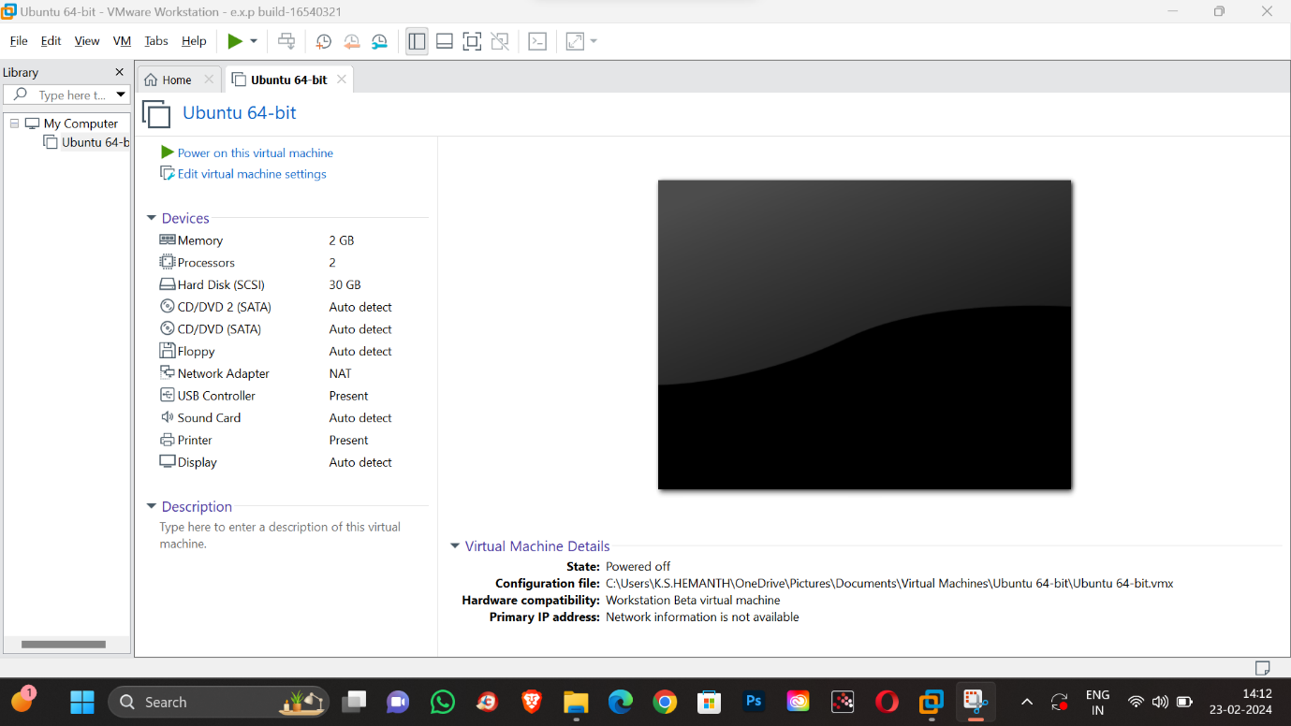

Step 2: Take a snapshot and save it as snapshot 1.

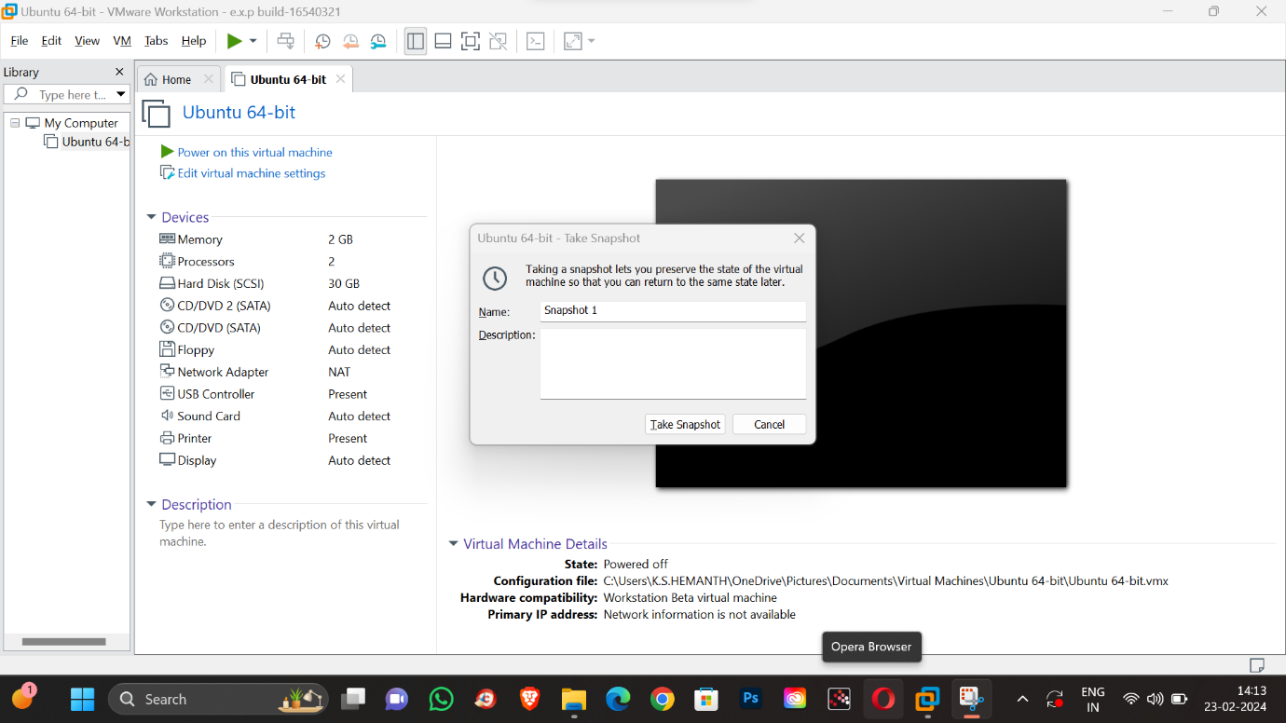

Step 3: change the RAM memory to 1 GB

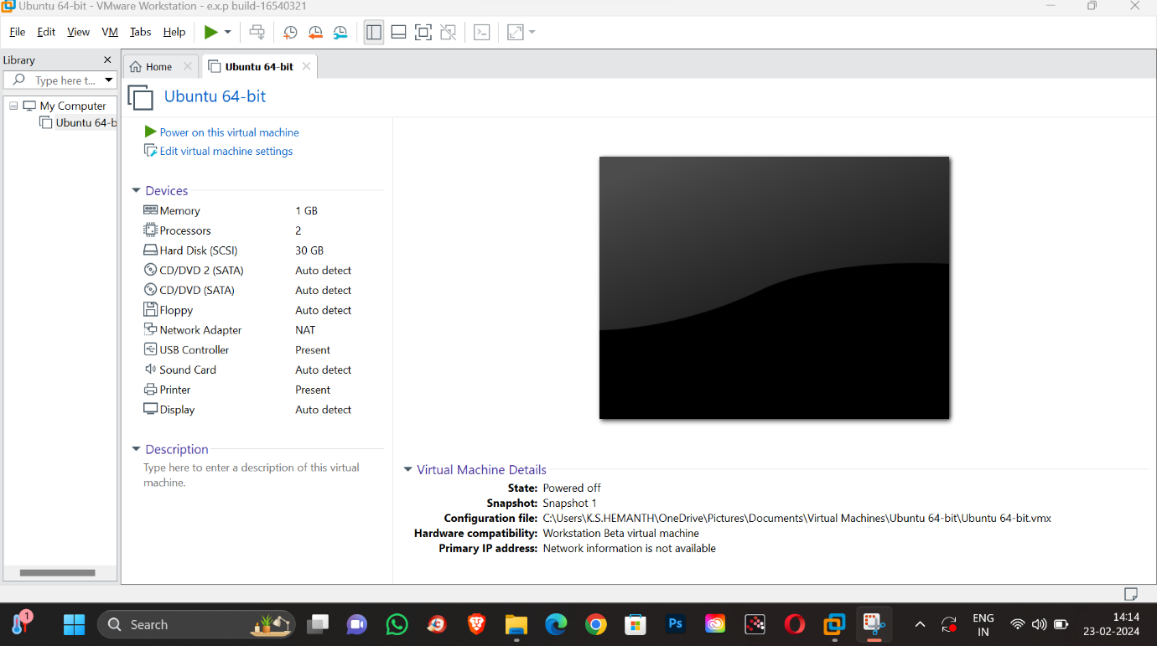

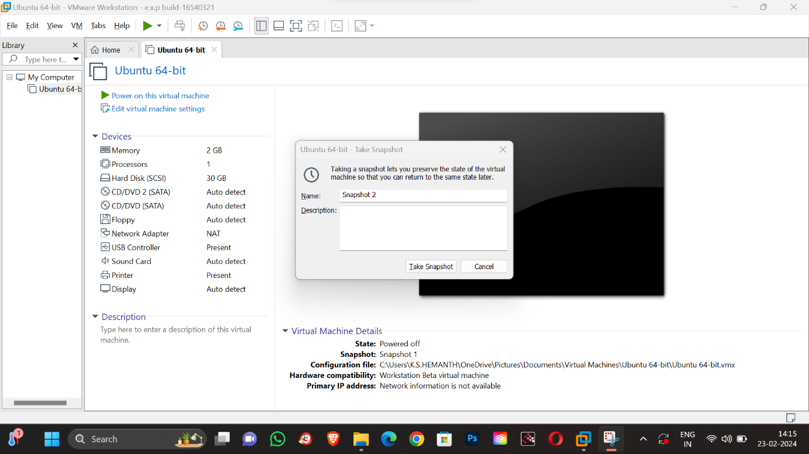

Step 4: change the processor core to core 1



Step 5: Take a snapshot answer save it as snapshot 2

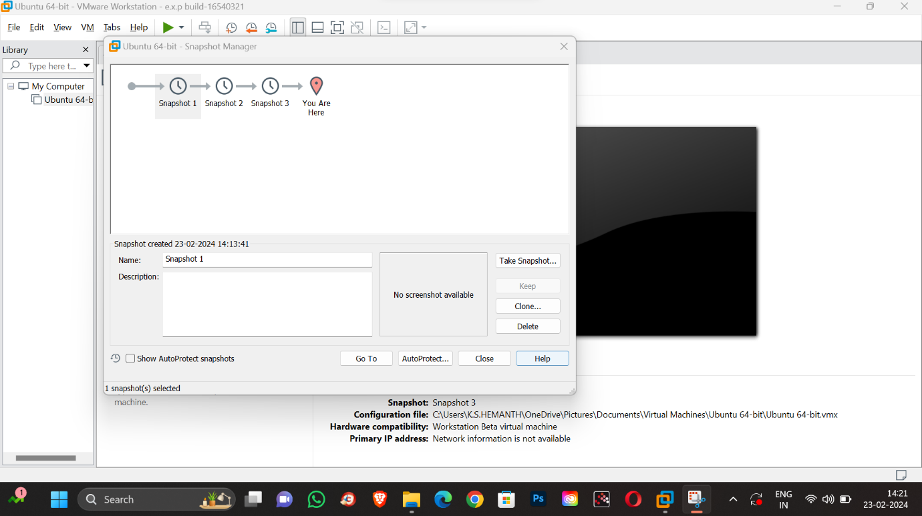

Step 6: Add the hard disk 15GB .

Step 7: take a snapshot and save it as snapshot 3.

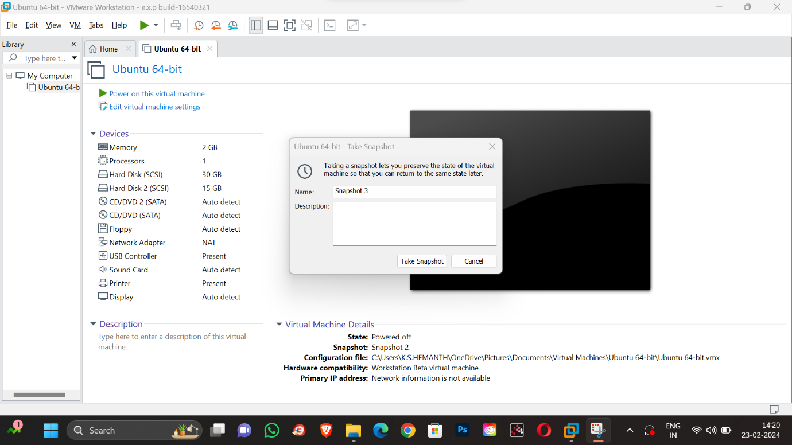

Step 8: open snapshot manager

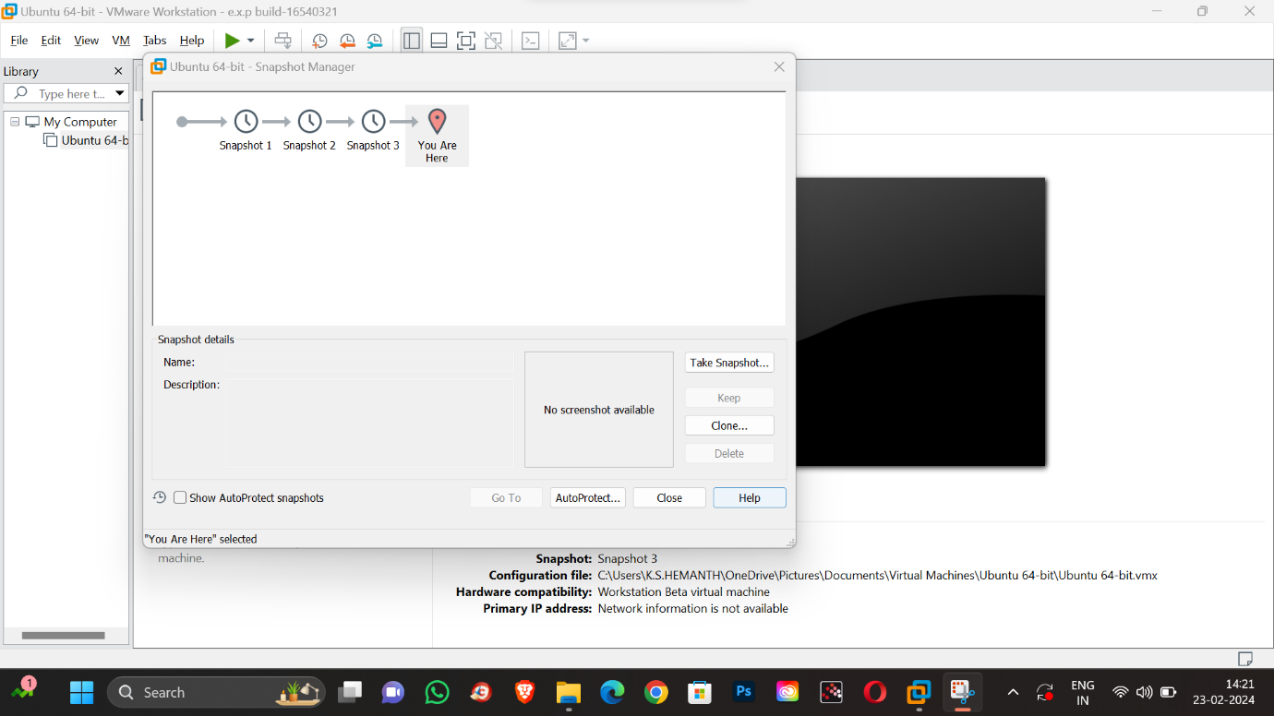

Step 9: choose snapshot 1 ,and switch to snapshot 1



Step 10: switch to snapshot 1 by clicking “go to”.

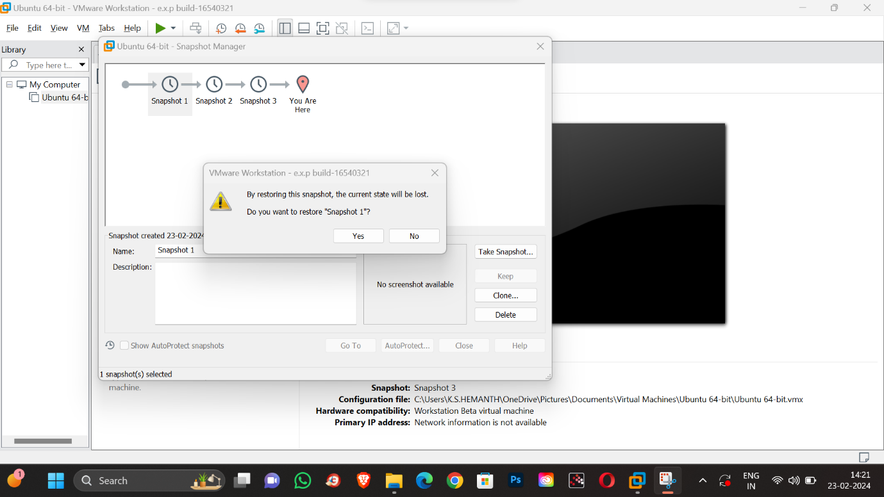

Step 11: click on “yes”

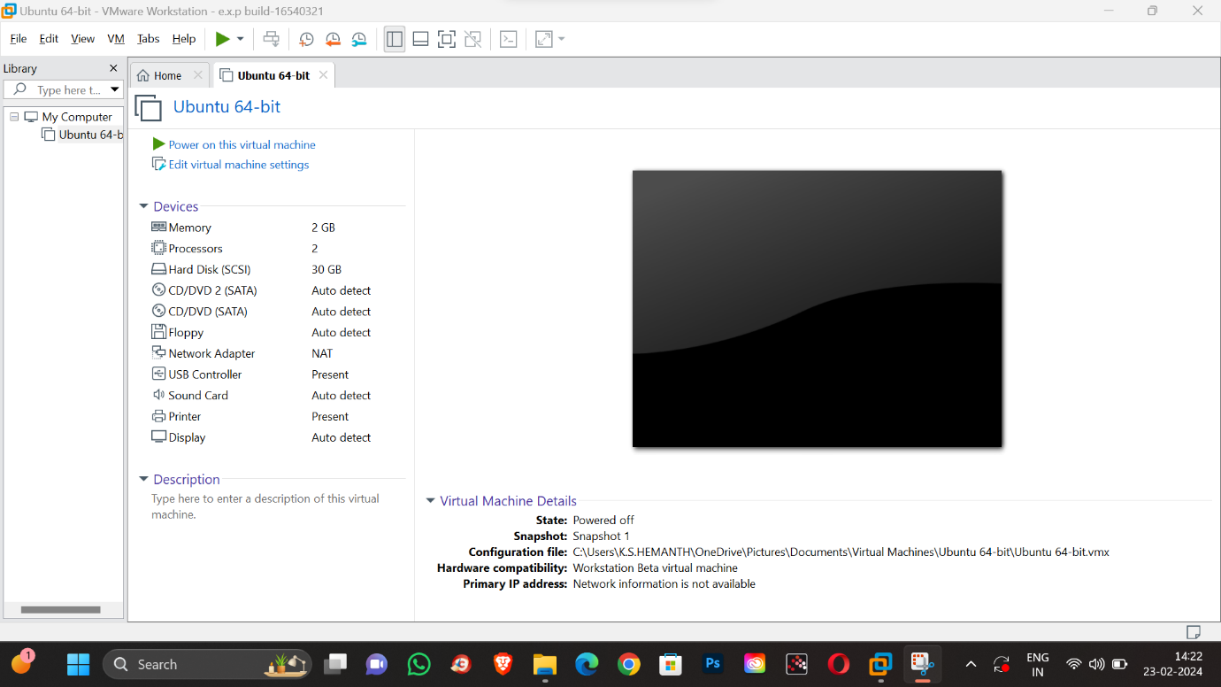

Step 12: the snapshot 1 has been retrieved .But the other snaps has been deleted .